BIOL 3043; Dr Corness
Take-home Exam
December 9th – December 18th 2020 11:59pm

For each section, read the paper that is referred to in order to answer the questions given. The answers can be gained from the lectures and the provided paper, although the test is open book so you may refer to outside sources. The questions asked on this test will refer to what is shown by the particular paper or lecture notes. You are not expected to consult other studies for full marks, unless you wish to. You will find the papers in the Contents section of D2L under the heading “Final Exam”.

Total marks: 100 + 5 bonus

___________________________________________________________________________

Please sign the following statement:

I have completed the Biology 3043 midterm exam to the best of my ability on my own. This means that during the exam, I have accessed the sources mentioned above, but have not discussed any of the questions or answers with anyone else by any means (whether in-person or on-line) before submitting my answers. While I understand that the exam is open book and that I can use the lecture slides, my notes, and the textbook, databases, and journal articles as resources; upon completion of the exam I will be able to honestly say that I have completed the test alone, using only the resources to which I will have referred.

___________________________________ ______________________
Signature Date

_______________________________________________________________________

Part 1: 50 points

Paper: Dehvari et al. Beta2-adrenoceptors increase translocation of GLUT4 via GPCR kinase sites in the receptor C-terminal tail. (2012)

The figure shown below is not necessarily needed for the questions. It is taken from: Rasmussen et al. Crystal structure of the human β2 adrenergic G-protein-coupled receptor. Nature 450:15 (2007).

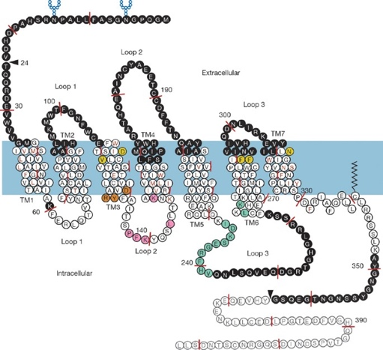

- The beta2-adrenergic receptor (beta2AR) is normally involved in inhibition of contraction in smooth muscle as part of the autonomic nervous system response to acute stress. What type of intracellular signalling is normally associated with beta2 signalling? (3)

Beta2 signalling is associated with endocrine signalling as the catecholamines that stimulate the receptor, adrenaline and nor-adrenaline are transported in blood and exert an effect on the circulatory system. The process of smooth muscle contraction is as follows;
The beta2-adrenergic receptor binds to the G-protein which activate adenylyl cyclase. Adenylyl cyclase catalyzes the secretion of cyclic AMP, thereafter, cAMP activates protein kinase A which phosphorylates myosin light chain kinase, causing smooth muscle contraction.

- What is the importance of the author stating that the effects of insulin and beta2AR on glucose uptake are not additive? (2)

The author states that the effects of insulin and beta2AR on glucose uptake are not additive to show that they are dependent on each other; Beta2AR stimulation stimulates insulin secretion, increasing glucose uptake, while beta2AR blockade inhibits insulin secretion and thus reduces glucose uptake. The beta2AR pathway does not involve phosphorylation of PKB while intermediate PKB is phosphorylated in the insulin pathway.

- What is the difference between zinterol and isoprenaline? (2)

Zinterol is a β1 and β2 mixed and non-selective receptor agonist while isoprenaline is a β2 selective receptor agonist.

- GLUT4 is endogenously expressed in adipocytes and skeletal muscles. What do the results of this paper suggest about the interaction of insulin with the glucose transporter(s) and how does this differ from zinterol? (4)
.
Insulin stimulates uptake of glucose by GLUT4 translocation to the plasma membrane. Insulin utilizes the P13-kinase/PKB translocation pathway whereby it binds to an insulin receptor on the cell membrane which undergoes a change that activates its tyrosine-kinase domain intracellularly. IRS and c-Cbl, the insulin receptor substrates are then phosphorylated. These substrates allow the translocation of GLUT4 by P13K, an effector molecule.
Zinterol, a β₂₋ Adrenoreceptor agonist stimulates glucose uptake by GLUT4 translocation via a different pathway, the downstream of GKR2 in which the Gβʏ subunits recruit GKR2 which facilitates phosphorylation of target residues.
βARKct inhibited glucose uptake and GLUT4 translocation in cells with the β2 adrenoreceptor following action of Zinterol agonist while in insulin stimulated glucose uptake, βARKct did not have any effect .
Zinterol-stimulated glucose uptake was significantly reduced in the truncated β₂ adrenoreceptor while insulin mediated glucose uptake was not affected.
Insulin increased glucose uptake in CHO-K1 cells transfected with only the β2 adrenoreceptor and in CHO-K1 cells transfected with only the GLUT4myc. On the other hand, no effect was observed on glucose uptake with zinterol agonist on either CHO-K1 cells transfected with only the β2 adrenoreceptor or in CHO-K1 cells transfected with only the GLUT4myc.

- What part of the beta2 adrenergic receptor is specifically shown to be responsible for direct G-protein coupling in this study? (2)

The part of the beta2 adrenergic receptor responsible for direct G-protein coupling is the helix 8 of the receptor.

- What was the purpose of myc in this experiment? How could the experiment have been carried out without the inclusion of myc? (6)

Myc was used as a marker of cell surface GLUT4 to promote the rapid and effective detection of GLUT4 and its translocation to the plasma membrane of other cells. The experiment could have been carried out without the inclusion of myc by the use of CHC control

- List the mutated beta2AR constructs used in this study (for which data is shown) and briefly describe them in terms of their purpose for studying the structure and/or function of the receptor? (Do not describe the results in this study, only describe the mutants used, and what they were designed to do based on sequence). (9)

The mutated beta2AR constructs used were;
Truncated β₂ adrenoreceptor; these were used to determine whether the C-terminus is important for β₂ adrenoreceptor agonist stimulated glucose uptake.

β₂ adrenoreceptor (-)PKA mutant; these were used to determine whether PKA sites were important for β₂ adrenoreceptor agonist stimulated glucose uptake.

β₂ adrenoreceptor (-)GRK mutant; these were used to determine whether GRK phosphorylation on GRK sites were important for β₂ adrenoreceptor agonist stimulated glucose uptake.

- Additional mutants were used in this study where the results were shown. Describe these mutants and why the results might have been considered redundant. Was the same result shown by other data? (10)

The additional mutants used were;
- The CHO-wtβ₂ adrenoreceptor- GLUT4 cells transfected with the GRK kinase dead mutant GRK2 K22OR; cotransfection with this mutant instead of the wild type GRK2 resulted in redundant results as GRK phosphorylation is crucial for glucose uptake.
- CHO-K1 cells transfected with only the β₂ adrenoreceptor and CHO-K1 cells transfected with only human GLUT4myc
These results were considered redundant as β₂ adrenoreceptor agonist-mediated glucose uptake requires the expression of both the beta2AR adrenoreceptor and GLUT4 transporter and also inhibiting GRK phosphorylation.
- CHO-GLUT4 cells transfected with βARKct and β₂ adrenoreceptor- These results were considered redundant as βARKct acts as a competitive inhibitor of GRK2 and binds to the Gβʏ subunits preventing the recruitment of kinase to the activated receptors.
YES, the result shown was the same as the one in the previous data.

- What do the results of figure 3 suggest about the interaction of beta2AR with GLUT4? (3)

The interaction of beta2AR and GLUT4, if the receptor is truncated is affected causing a reduction in glucose uptake. Truncation of the receptor involves removal of the C-terminal tail which has the sites for GRK phosphorylation.This GRK phosphorylation site is important for GLUT4 translocation and B2 adrenoceptor stimulated glucose uptake.

- List 4 ways in which the involvement of GRK in glucose uptake was demonstrated in this study (9).

- Use of the β₂ adrenoreceptor (-)GRK mutant.
- Use of the truncated β₂ adrenoreceptors.
- Cotransfection of CHO-GLUT4 cells in β₂ adrenoreceptor agonist mediated cells with βARKct.
- Contransfection of GRK2 K22OR,the GRK kinase dead mutant, in CHO-wtβ₂ adrenoreceptor- GLUT4 cells, instead of the wild type GRK2.

Part 2: 40 points

Suofu at al. Dual role of mitochondria in producing melatonin and driving GPCR signaling to block cytochrome c release. (2017)

- Describe the model cell systems used in this study and the advantages of each. (5)

The use of male mice; mitochondria from mice brain were used to determine the presence of melatonin receptor(MT1) in the mitochondrial membrane. The advantage of the mice models is that they’re cheap and easy to maintain. Their genotype is also well-defined(Moran, et al.,2016).

N2a cells which are mice neuroblastomas to investigate MT1 signalling. The advantage of this model is that they have a faster growing rate compared to other cells in neural origin. They are also important models in studies related to epileptic activity(Kim, et al.,2013).

Transgenic mouse model to investigate neuronal damage. The advantage of this model is that they are useful in determining the cause,development and treatment of diseases and they allow scientists to undertake drug trials which give results faster as compared to drug trials on humans(genetargeting.com).

- What new information was shown in this study about the synthesis of melatonin and how was this demonstrated? (5)

Melatonin is synthesized in the matrix of mitochondria and then released by the organelle to bind to the melatonin type 1 receptor (MT1) . This was demonstrated by experiments to determine whether the enzymes responsible for synthesis of melatonin were present and active in mitochondria. These enzymes are Aralkyly-amine N-acetyltransferase(AANAT) and acetylserotonin O-methyltransferase(ASMT). Qualitative mass spectrometry was utilized to detect the conversion of d4-serotonin to the intermediate d4-n-acetylserotonin and to the final product d4-melatonin in mitochondria.

- How is melatonin receptor density shown by the results in the paper and what does it specifically reveal? (3)

Melatonin receptor binding is determined by the saturation binding of melatonin. This was determined by obtaining the saturation binding data of melatonin and iodomelatonin on the receptors on the plasma membrane and mitochondria. The results were best fit through a nonlinear regression analysis.

This data reveals that melatonin has equal range affinity for the melatonin receptors on the plasma membrane and mitochondria.

- List the experiments that show that melatonin is necessary and sufficient in neuroprotection. (6)

The experiments showing that melatonin is necessary and sufficient in neuroprotection are;

- Measuring the affinity of melatonin for binding to melatonin receptors located on the plasma membrane and mitochondria.
- Determining the effect of luzindole on melatonin; luzindole is an antagonist to the inhibitory effects of melatonin on the production of cAMP and cytochrome c release.
- Comparing apoptosis and neurological scores between wild type and MT1-GFP transgenic mice at different periods of time after permanent middle cerebral artery occlusion.
- Using immuniblotted lysates to investigate the presence of Gαi in the intermembrane mitochondrial space.
- The use of FRET-based cAMP sensors localized in the plasma membrane or the outer mitochondrial membrane to determine the ability of melatonin to inhibit cAMP production mediated by forskolin.

- Which experiment was used to show that MT1 is on the outer mitochondrial membrane? Explain briefly how this experiment worked. (5)

The experiment used to show that MT1 is on the outer mitochondrial membrane was the use of constructs. The first step involved electron microscopy which detected staining in mitochondria pellets from cells expressing the mMT1-FLAG. The 2nd step involved staining and the use of expansion microscopy which identified colocalization of TOM20 and hMT1-FLAG. In the 3rd step,immunoblotting experiments revealed 2 selective protein bands that are specific to hMT1-FLAG ,one at ≈40 and the other at 33kDa. To characterize these bands, the glycosylation sites in MT1 were mutated. These are Asparagine 4 and 10 to isoleucine. As a result, the 2 bands joined into 1 band at 33kDa. This demonstrated the presence of MT1 receptor on the mitochondrial membrane.

- What is the difference between the MT ligands used in the study and what do the results with them tell us? (5)

The difference between melatonin and iodomelatonin is that iodomelatonin has a higher affinity to the melatonin receptors than melatonin. The results of the study show that melatonin and iodomelatonin bind to both the receptors on the plasma membrane and the mitochondrion.

- Explain the results in Figure 3C and speculate on the significance. (4)

Figure C shows the immunoblot of control N2a cell lysates and MT₁FLAG. In the experiment, 2 selective protein bands that are specific to hMT1-FLAG were observed, one at ≈40 and the other at 33kDa. To characterize these bands, the glycosylation sites in MT1 were mutated. These are Asparagine 4 and 10 to isoleucine. As a result, the 2 bands joined into 1 band at 33kDa. The red arrow signifies a background band, the green arrow represents glycosylated MT1 while the blue arrow indicates non-glycosylated MT1 .The higher band is the glycosylated form of the receptor MT1.

The significance of the experiment is to demonstrate the presence of MT1 receptor on the mitochondrial membrane.

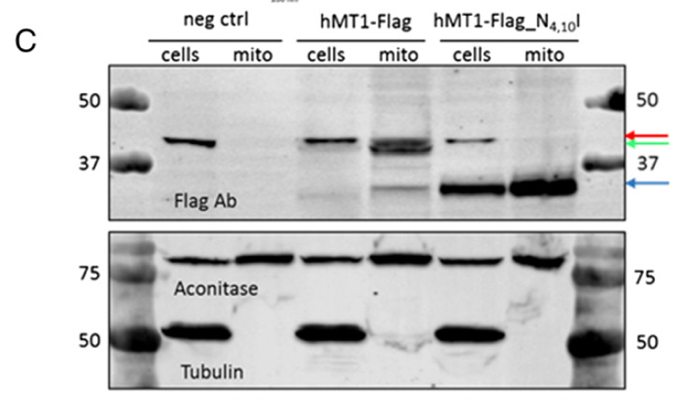

- In Figure 5A, what might be the reason for the significant difference between the second and fifth bar? (3)

In the 2nd bar, cell death is at a higher percentage while in the 5th bar, apoptosis is at a lower percentage. This is due to melatonin treatment of PCN isolated from the wild type mice which inhibited OGD-induced death by providing added neuro-protection. On the other hand, the wild type PCN had higher cell death percentages as it was not exposed to the melatonin receptor.
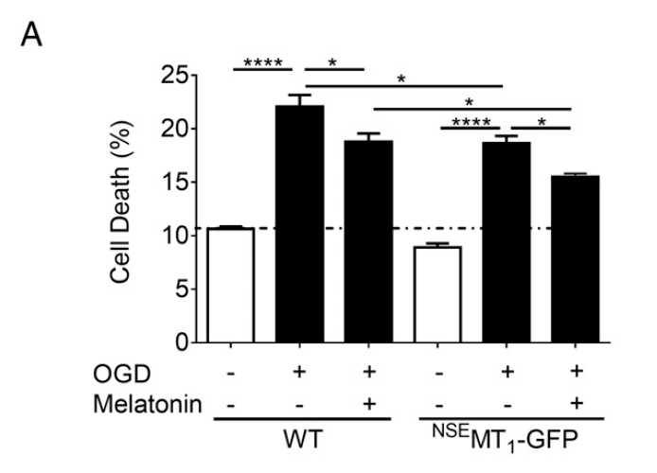
- What criticism or comments can you make with respect to validity of this paper? (2)

The paper is quite educational and extensively informs about the role of the mitochondria in producing melatonin and regulating the GPCR signalling which inhibits cytochrome c release and prevents apoptosis.

- Suggest a further study to follow up these results and explain why you think it would be important. (2)
I would suggest a study to investigate the action of melatonin in vivo. This would be important as it would further demonstrate the protective action of melatonin endogenously.

Part 3: 15 points

Borges et al. Massive dissemination of a SARS-CoV-2 Spike Y839 variant in Portugal. (2020)

(Supplementary material for this article does not need to be accessed)

The questions are best answered for the most part from the lecture material.

- What is a type IV virus under the Baltimore classification system? (1)

A type IV virus under the Baltimore classification system has a single stranded RNA with positive polarity. Its genome functions as the mRNA.

- In what way is the genetic fidelity unique among coronaviruses and what gene is responsible? (3)

Coronaviruses employ exoribonuclease activity and encode this enzyme in non-structural proteins with known RNA synthesis, specifically the non-structural protein number 14(nsp14). This enzyme is responsible for the replication of the virus.The gene responsible is the G24077T.

- Describe the Pfizer vaccine currently being distributed in simple terms. (2)

The Pfizer corona virus vaccine is made up of messenger RNAs and stimulates the body to produce fragments of the virus’s spike protein which induces neutralizing antibodies that help in the fight against the Covid-19.

- What is the purpose of the SARS-CoV-2 spike protein and how is this affected by the mutation presented in this paper? Describe the mutation and its putative impact (7)

The spike protein is responsible for the binding of the SARS-CoV-2 with its receptor ACE2 in the human cells and thus the entry of the virus into human body.The spike protein also induces neutralizing antibodies.
The SARS-CoV-2 spike Y839 variant, has an spike amino acid within the fusion peptide or proximal regions. It was caused by a mutation in the D614G variant and it is believed to structurally alter the spike protein such that it fuses better with human cells. This could strengthen the interaction between the virus and the T cells and subsequently influence inflammatory responses of the host.
Impacts of the mutation
An increase in the transmissibility of the virus which is demonstrated by lower ct levels.
The mutation could result in reduced inflammatory responses to the virus.

5)Why would it be important to continue monitoring the sequence of SARS-CoV-2 even after widespread use of a vaccine? (2)

Continuous mutation of the amino acid sequence on the spike protein might result in faster transmissions of the virus and may reduce the effectiveness of the vaccine. As a result, updated vaccines may need to be developed to battle the new mutations.

References

@GeneTargeting (2018). Transgenic Mouse Model: What are the benefits and drawbacks?. https://www.genetargeting.com/transgenic/transgenic-mouse-model/

@adsabs (NaN). Mouse neuroblastoma cell based model and the effect of epileptic events on calcium oscillations and neural spikes. http://ui.adsabs.harvard.edu/abs/2013SPIE.8879E..0TK/abstract

Moran, C. J., Ramesh, A., Brama, P. A., O'Byrne, J. M., O'Brien, F. J., & Levingstone, T. J. (2016). The benefits and limitations of animal models for translational research in cartilage repair. Journal of experimental orthopaedics, 3(1), 1. https://doi.org/10.1186/s40634-015-0037-x

